The MultiSIM files are organized by chapter number. The files are divided into folders, one for each chapter. The name of the file provides a wealth of information to the user. They will have the same name of the chapter within the text book and the example or problem within the chapter for which they should be used. For example: the MultiSIM file that corresponds to Example 1-4 would be labeled Ch1 Example 1-4. The file will be located in the folder labeled Chapter 1.
To open a file, start MultiSIM 8 and then either mouse click on the word “File” located on the drop down menu bar and then mouse click on the Open command or mouse click on the open folder icon located on the tool bar as shown in Figure 1. Both methods will cause the Open File dialog box shown in Figure 2 to pop open. Navigate to the appropriate chapter folder and retrieve the file needed.
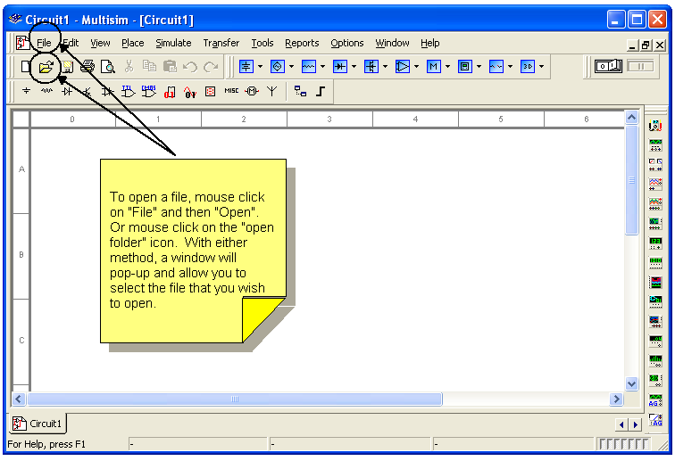
Figure 1, Opening a File
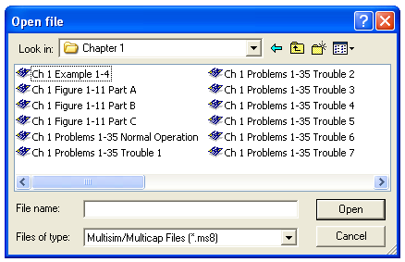
Figure 2, Open File Dialog Box

